SQL Agent Jobs Running Report - SQL Server
https://gallery.technet.microsoft.com/scriptcenter/Get-Information-on-All-f0812196
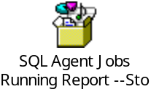
The SQL server Jobs which are running on a Instance are very Important.
As a DBA you need to take care of these Jobs and have all information about the Job.
Your will get information on Jobs is SysJobs but again not in the way you want.
So just thought of pulling the Job information and below is the stored Procedure for the same.

This procedure give information on
[job_id],
[Jobs],
[Category],
[Owner],
[Schedule Name],
[enabled],
[Frequecy],
[DateCreated],
[StartDate],
[NextRunDate],
[NextRunTime]

Create the Attached SP on MSDB Database and execute below TSQL to get the Job executions report.
use msdb
go
exec spGetJobInfo
Sample output:
